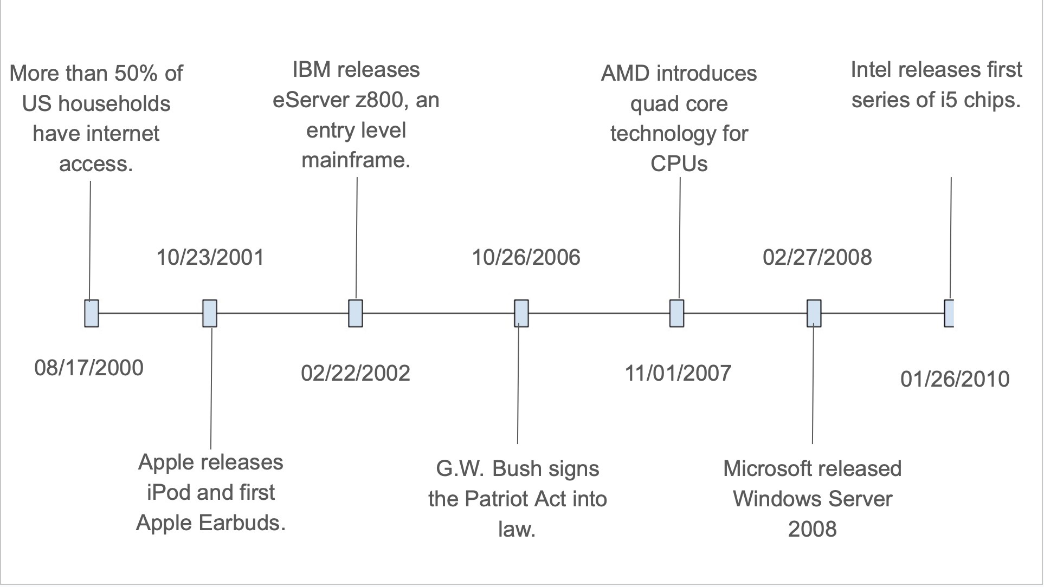

First, at the beginning of the millennium, we had over 50% of US households having access to the internet. I felt this was important because it showed the increasing demand for computers, and their overall advancement, further fueling innovation in the field. Then in 2001 we had one of the now tech giants, Apple, release the first iPod and Apple Earbuds. This release and eventual popularization proved the demand for personal miniaturized mobile devices, truly foreshadowing the company’s future endeavors. Then in 2002 IBM released the eServer z800, allowing for smaller businesses or organizations to have access to elevated computing power. Then in 2006 President Bush signed the Patriot Act, limiting restrictions the US government had on monitoring its citizens. I felt that this was important because it brought a lot of attention to the tech and computing field. Then in late 2007 AMD introduced quad core technology for its CPUs, which would become the sort of base series for the foreseeable future AMD processors. Then in 2008 Microsoft released Windows Server 2008, which would be massively utilized, still even being used by many organizations and businesses today. Finally in 2010, Intel releases the first iteration of their i5 processors, which would become Intel’s standard series for the foreseeable future.